Valentine’s Day spending blooms within an otherwise tough month for the retail sector
AUCKLAND, 5 March 2025 – Consumer spending across New Zealand reverted to its slight downward trend in the last three weeks of February with the notable exception of Valentine’s Day, according to figures released today by Worldline NZ.

Consumer spending through Core Retail merchants in Worldline NZ’s payments network in February 2025 reached $3.67B, which is down -4.8% on February 2024.
Worldline NZ’s Chief Sales Officer, Bruce Proffit says the size of the monthly decline mostly reflects the fact that there was an extra day in February 2024 due to the leap year, but is partly because that spending was down on 2024 in three of the four weeks of the month.
“In short, the tough retail environment of 2024 is clearly continuing into 2025,” says Proffit.
“The small positive growth rate seen in January did persist into the first week of February but we then saw spending drop on last year amongst Core Retail merchants in Worldline’s network for the following three weeks.”
Proffit also notes that spending was running -0.7% below last year in the last week of February.
“However, tight budgets did not dampen the romantic flame this year, with Valentine’s Day seeing a notable upwards spike in spending at florists and jewellers, and – to a slightly lesser extent – at a few other related merchant groups on the Thursday and Friday of 13 and 14 February.”
Spending at florists, jewellers, chemists, bookshops and cafés and restaurants in Worldline NZ’s payments network was $51.2m on Thursday, 13 February, and Friday, 14 February, combined, which is up 16.3% on the same two days in 2024.
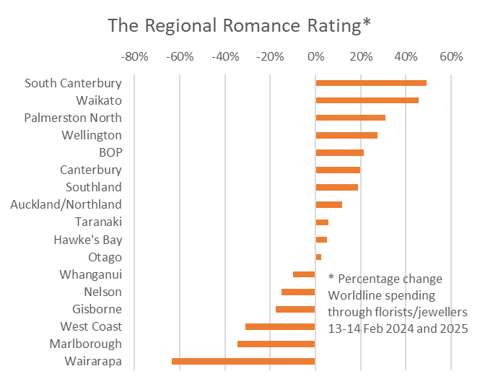
Figure 1: All Cards NZ regional spending growth through Worldline for Florists and Watch/Jewellery merchants – percentage change between Tue/Wed 13/14th February 2024 and Thur/Fri 13/14th February 2025
“Our traditional Regional Romantic Rating, based on annual spending growth at florists and jewellers, showed that South Canterbury and the Waikato regions were feeling the most Valentine’s Day love this year as they saw the largest spending increase at these retailers.”
Meanwhile, regional Core Retail spending growth for the full month of February was strongest in Whanganui (+1.0%) and weakest in Auckland/Northland (-7.0%), Wellington (-6.5%), Marlborough (-6.5%) and Bay of Plenty (-6.0%).
WORLDLINE All Cards underlying* spending for CORE RETAIL merchants for February 2025
 | Value | Underlying value*
Region | transactions $millions | Annual % change on 2024
Auckland/Northland | 1,326 | -7.0%
Waikato | 302 | -2.1%
BOP | 253 | -6.0%
Gisborne | 33 | -0.9%
Taranaki | 87 | -2.6%
Hawke's Bay | 134 | -2.4%
Whanganui | 50 | 1.0%
Palmerston North | 106 | -5.7%
Wairarapa | 45 | -0.7%
Wellington | 311 | -6.5%
Nelson | 81 | -4.9%
Marlborough | 53 | -6.5%
West Coast | 35 | -2.7%
Canterbury | 447 | -2.5%
South Canterbury | 62 | -3.3%
Otago | 249 | -1.3%
Southland | 97 | -4.4%
New Zealand | 3,675 | -4.8%
Figure 2: All Cards NZ underlying* spending through Worldline in February 2025 for core retail merchants (* Underlying excludes large clients moving to or from Worldline)
- ENDS -
Note to editors:
These figures reflect general market trends and should not be taken as a proxy for Worldline‘s market share or company earnings. The figures primarily reflect transactions undertaken within stores but also include some ecommerce transactions. The figures exclude transactions through Worldline undertaken by merchants outside the Core Retail sector (as defined by Statistics NZ).

For more information, contact:
Brendan Boughen
T 027 839 6044
E brendan.boughen.external@worldline.com

ABOUT WORLDLINE IN NEW ZEALAND
We are New Zealand's leading payments innovator. We design, build and deliver payment solutions that help Kiwi business succeed. Whether you’re looking for in store, online or mobile payment solutions or powerful business insights, Worldline is here to help with technology backed by experience. www.worldline.co.nz

About Worldline
Worldline [Euronext: WLN] helps businesses of all shapes and sizes to accelerate their growth journey – quickly, simply, and securely. With advanced payments technology, local expertise and solutions customised for hundreds of markets and industries, Worldline powers the growth of over one million businesses around the world. Worldline generated a 4.6 billion euros revenue in 2024. worldline.com
Worldline’s corporate purpose (“raison d’être”) is to design and operate leading digital payment and transactional solutions that enable sustainable economic growth and reinforce trust and security in our societies. Worldline makes them environmentally friendly, widely accessible, and supports social transformation.
Press Contact
Hélène Carlander
T +33 7 72 25 96 04
E helene.carlander@worldline.com
Follow us

