Auckland, Wellington, or Canterbury - Where’s the cheapest place to rent?
- Average rental prices down in Auckland and Wellington
- Wellington renters could save $3,000 a year, with Aucklanders following at $1,560
- Canterbury rents stable, but renters spend a higher share of income on rent
Kiwis spend a significant portion of their household income on rent. So, how do our three most populated regions—Auckland, Wellington, and Canterbury—compare?
New data from realestate.co.nz reveals that renters in Wellington and Auckland may be paying less than they were a year ago, while prices in Canterbury remain stable.
Wellington has seen the biggest drop, with rental prices down 8.0% since February 2024 to $673 per week, potentially saving renters $3,016 a year. Auckland follows with a 4.1% decline to $689 per week, equating to annual savings of $1,560. Meanwhile, Canterbury’s rental prices have remained relatively steady, down just 0.4% to $586 per week, with minimal savings of $104 a year, or just $2 per week.
Vanessa Williams, spokesperson for realestate.co.nz, says these changes reflect shifting rental market conditions but warns against assuming lower rent prices translate to immediate financial relief:
“While lower average rents indicate a more tenant-friendly market in Auckland and Wellington, renters may not immediately experience these savings. Those on fixed-term leases may still be paying higher rents, so new renters or those renewing agreements are more likely to benefit.”
Despite stable prices, Canterbury renters spend a slightly higher proportion of their income on rent compared to those in Auckland and Wellington.
Using Stats NZ’s most recent household income data (June 2024) as a benchmark, the estimated proportion of household disposable income spent on rent in February 2025 would be 29.7% in Auckland, 29.8% in Wellington, and 30.6% in Canterbury.
Going by the common ‘30% of income on rent’ affordability rule, rental costs in all three cities sit near this threshold. However, Williams cautions that this benchmark doesn’t reflect individual circumstances. “Affordability isn’t just about rent; it’s about income and other living costs, including inflation, rising grocery and utility prices, and whether wages have kept pace with overall expenses.”
“Nationally, we have seen rents trend downwards over the last 12 months, reflecting the broader economic challenges facing many Kiwis.”
Frances Cook, finance journalist and Making Cents podcast host says the rental price drops will be good news and says that 30% affordability ratio advice is unrealistic for many renters:
“This will be welcome news to many renters, as housing is one of the biggest costs in the average budget. The standard advice is to try not to spend more than 30% of your income on housing, but frankly, that’s been really difficult for a while now. For many people, it was nudging up past 50% of their income, going towards just keeping a roof over their heads. If you can snag one of these cheaper properties, and then start working on a pay rise, that’s a double hit that would help a lot of people.”
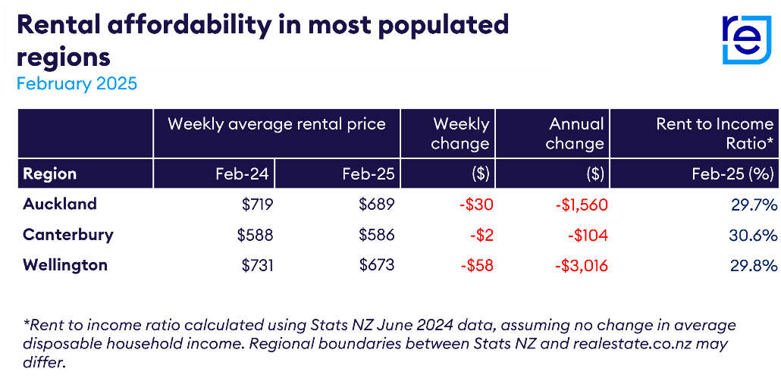
ENDS
Sources
- realestate.co.nz rental data (February 2025)
- Stats NZ household income data (June 2024)
Note: All figures are based on the latest available data as of February 2025. Regional boundaries between realestate.co.nz and Stats NZ may differ.
For media enquiries, please contact:
Brigid Conroy | brigid@brainchild.co.nz | Brainchild

About realestate.co.nz
We’ve been helping people buy, sell, or rent property since 1996. Established before Google, realestate.co.nz is New Zealand’s longest-standing property website and the official website of the real estate industry.
Dedicated only to property, our mission is to empower people with a property search tool they can use to find the life they want to live. With residential, lifestyle, rural and commercial property listings, realestate.co.nz is the place to start for those looking to buy or sell property.
Whatever life you’re searching for, it all starts here.
Want more property insights?

- Market insights: Search by suburb to see median sale prices, popular property types and trends over time.
- Sold properties: Switch your search to sold to see the last 12 months of sales and prices.
- Valuations: Get a gauge on property prices by browsing sold residential properties, with the latest sale prices and an estimated value in the current market.
Glossary of terms:

Average asking price (AAP) is neither a valuation nor the sale price. It is an indication of current market sentiment. Statistically, asking prices tend to correlate closely with the sales prices recorded in future months when those properties are sold. As it looks at different data, average asking prices may differ from recorded sales data released simultaneously.

New listings are a record of all the new residential dwellings listed for sale on realestate.co.nz for the relevant calendar month. The site reflects 97% of all properties listed through licensed real estate agents and major developers in New Zealand. This description gives a representative view of the New Zealand property market.

Stock is the total number of residential dwellings that are for sale on realestate.co.nz on the penultimate day of the month.

Rate of sale is a measure of how long it would take, theoretically, to sell the current stock at current average rates of sale if no new properties were to be listed for sale. It provides a measure of the rate of turnover in the market.

Seasonal adjustment is a method realestate.co.nz uses to represent better the core underlying trend of the property market in New Zealand. This is done using methodology from the New Zealand Institute of Economic Research.

Truncated mean is the method realestate.co.nz uses to supply statistically relevant asking prices. The top and bottom 10% of listings in each area are removed before the average is calculated to prevent exceptional listings from providing false impressions.

