Pre-Christmas spending across NZ continues slightly up on last year, but not everywhere
AUCKLAND, 16 December 2024 – Consumer spending across New Zealand in the first 14 days of December has continued to trend up on the same time last year, although some regions have shown stronger growth than others.

Consumer spending processed through all Core Retail merchants (excluding Hospitality) in Worldline NZ’s payments network during the first 14 days of December reached $1.65B, which is up +1.2% on the first 14 days of December 2023.
Worldline NZ’s Chief Sales Officer, Bruce Proffit, says while the usual December spending build-up to Christmas Day remains slightly above the same time last year, there are mixed patterns across the regions.
“Although spending at this point in December is slightly up on last year, the rate of growth did slip a little in the second week,” he says.
Proffit notes that spending growth was strongest in Wairarapa (+6.0%), Whanganui (+5.2%), Hawke’s Bay (+4.8%) and Gisborne (+4.8%), but below year-ago levels in Palmerston North (-0.9%), Wellington (-0.7%), Bay of Plenty (-0.7%), Auckland/Northland (-0.3%) and Marlborough (-0.1%).
He also notes that the average transaction value for the first two weeks of December is slightly down on last year, being $51.47 this year, down -1.1% on the $52.05 average in 1-14th December 2023.
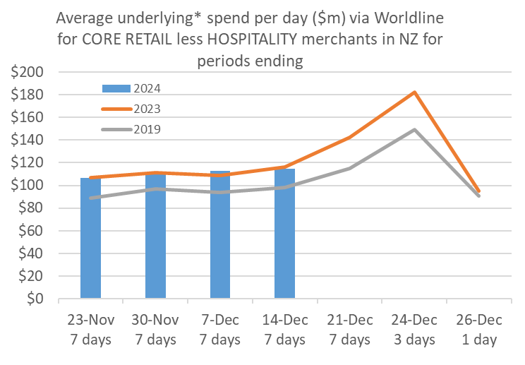
Figure 1: All Cards NZ average daily underlying* spending through Worldline for core retail excluding Hospitality in the leadup to Christmas Day, plus Boxing Day (* Underlying excludes large clients moving to or from Worldline)
“There is plenty of Christmas shopping still to come but, judging by the pattern of trading across the various retail sectors so far this month, we could expect to find more clothes (+2.9% on 2023) and sporting equipment (+14.2%) under the tree this year and fewer books (-3.6%) and home decorations (-4.9%),” says Proffit.
Proffit also notes there has been a drop in spending through Food and Liquor service merchants in Worldline NZ’s network over the last two weeks, which is traditionally part of the window for workplace Christmas parties.
“Spending through these merchants was $422m during the first 14 days of December, down -0.5% on the first 14 days of December 2023,” he says.
“Based on patterns seen in 2019 when Christmas also fell on a Wednesday, we’ll likely see an increase in spending in this sector this week, which will likely peak this coming weekend.”
WORLDLINE All Cards underlying* spending for CORE RETAIL less HOSPITALITY merchants for 1-14th Dec 2024
 | Value | Underlying*
Region | transactions $millions | Annual % change on 2023
Auckland/Northland | 609.9 | -0.3%
Waikato | 140.7 | 2.8%
BOP | 110.8 | -0.7%
Gisborne | 15.2 | 4.8%
Taranaki | 38.7 | 1.4%
Hawke's Bay | 63.1 | 4.8%
Whanganui | 23.7 | 5.2%
Palmerston North | 51.0 | -0.9%
Wairarapa | 21.5 | 6.0%
Wellington | 144.0 | -0.7%
Nelson | 34.8 | 3.2%
Marlborough | 21.5 | -0.1%
West Coast | 11.7 | 1.8%
Canterbury | 203.6 | 2.7%
South Canterbury | 29.2 | 4.6%
Otago | 93.1 | 4.1%
Southland | 37.4 | 1.6%
New Zealand | 1,650.5 | 1.2%
Figure 2: Recent All Cards NZ underlying* spending growth through Worldline for regional core retail excluding hospitality merchants, versus the same dates in the previous year (* Underlying excludes large clients moving to or from Worldline)
- ENDS -

Note to editors:
These figures reflect general market trends and should not be taken as a proxy for Worldline‘s market share or company earnings. The figures primarily reflect transactions undertaken within stores but also include some ecommerce transactions. The figures exclude transactions through Worldline undertaken by merchants outside the Core Retail sector (as defined by Statistics NZ).

For more information, contact:
Brendan Boughen
T 027 839 6044
E brendan.boughen.external@worldline.com

ABOUT WORLDLINE IN NEW ZEALAND
We are New Zealand's leading payments innovator. We design, build and deliver payment solutions that help Kiwi business succeed. Whether you’re looking for in store, online or mobile payment solutions or powerful business insights, Worldline is here to help with technology backed by experience. www.worldline.co.nz

About Worldline
Worldline [Euronext: WLN] helps businesses of all shapes and sizes to accelerate their growth journey – quickly, simply, and securely. With advanced payments technology, local expertise and solutions customised for hundreds of markets and industries, Worldline powers the growth of over one million businesses around the world. Worldline generated a 4.6 billion euros revenue in 2023. worldline.com
Worldline’s corporate purpose (“raison d’être”) is to design and operate leading digital payment and transactional solutions that enable sustainable economic growth and reinforce trust and security in our societies. Worldline makes them environmentally friendly, widely accessible, and supports social transformation.
Press Contact
Hélène Carlander
T +33 7 72 25 96 04
E helene.carlander@worldline.com
Follow us

