In the first week of Christmas, we started stocking up
AUCKLAND, 10 December 2024 – Consumer spending across New Zealand was up in the first seven days of December, both on the previous week and on the first seven days of December last year.

Consumer spending processed through all Core Retail merchants (excluding Hospitality) in Worldline NZ’s payments network during the first full week of December reached $818m, which is up 3.8% on the same week of December 2023.

Worldline NZ’s Chief Sales Officer, Bruce Proffit, says after several months of consumer spending trending below year-ago levels, it will be encouraging for retailers to see a more positive start to the usual December build-up to Christmas Day.
“It’s notable that spending in the seven days to Saturday, 7th December, which caught some of the extended run of the Black Friday sales, was both higher (+1.2) than the last seven days of November – which included Black Friday itself – and higher than the first seven days of December last year,” says Proffit.
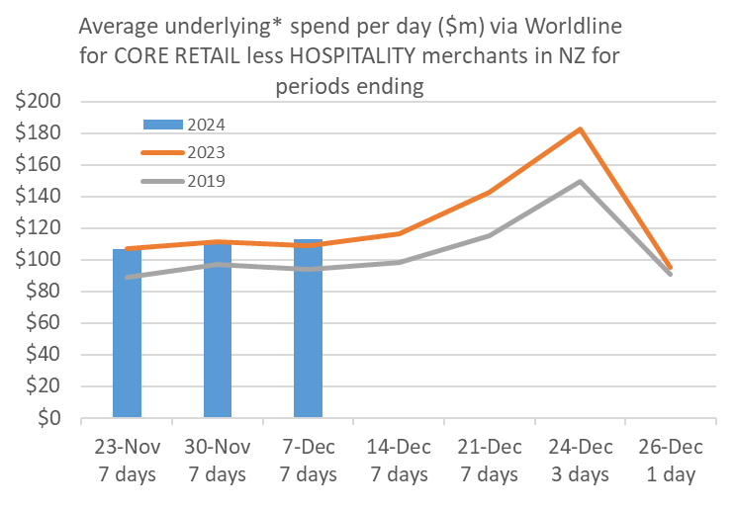
Figure 1: All Cards NZ average daily underlying* spending through Worldline for core retail excluding Hospitality in the leadup to Christmas Day (* Underlying excludes large clients moving to or from Worldline)
“The spending increase on the same week of December last year was seen across a wide range of merchants, while the increase in spending on the last week of November was due to a step-up in Food and Liquor purchases, as most other merchants saw some decline after the Black Friday rush,” says Proffit.
“Traditionally, spending will continue to increase as we move closer to Christmas Day and consumers stock up, with the peak likely to be on Christmas Eve for the Food and Liquor shops, based on the 2019 pattern when Christmas Day was also a Wednesday.”
Spending in the first 7 days of December was up strongest on last year in Hawke’s Bay (+9.1%), Wairarapa (+8.8%) and Gisborne (+7.6%). The annual spending growth was lowest in Palmerston North (+0.4%), Wellington (+0.7%), Bay of Plenty (+1.7%) and Marlborough (+1.7%).
WORLDLINE All Cards underlying* spending for CORE RETAIL less HOSPITALITY merchants for 1-7th Dec 2024
 | Value | Underlying*
Region | transactions $millions | Annual % change on 2023
Auckland/Northland | 304.8 | 3.5%
Waikato | 69.5 | 5.6%
BOP | 54.8 | 1.7%
Gisborne | 7.5 | 7.6%
Taranaki | 18.8 | 2.2%
Hawke's Bay | 31.6 | 9.1%
Whanganui | 11.8 | 6.8%
Palmerston North | 25.1 | 0.4%
Wairarapa | 10.8 | 8.8%
Wellington | 71.6 | 0.7%
Nelson | 17.1 | 5.4%
Marlborough | 10.6 | 1.7%
West Coast | 5.8 | 3.4%
Canterbury | 99.9 | 3.8%
South Canterbury | 14.4 | 6.9%
Otago | 46.2 | 6.9%
Southland | 18.4 | 2.5%
New Zealand | 818.8 | 3.8%
Figure 2: Recent All Cards NZ underlying* spending growth through Worldline for regional core retail excluding hospitality merchants, versus the same dates in previous years (* Underlying excludes large clients moving to or from Worldline)
- ENDS -

Note to editors:
These figures reflect general market trends and should not be taken as a proxy for Worldline‘s market share or company earnings. The figures primarily reflect transactions undertaken within stores but also include some ecommerce transactions. The figures exclude transactions through Worldline undertaken by merchants outside the Core Retail sector (as defined by Statistics NZ).
For more information, contact:
Brendan Boughen
T 027 839 6044
E brendan.boughen.external@worldline.com

ABOUT WORLDLINE IN NEW ZEALAND
We are New Zealand's leading payments innovator. We design, build and deliver payment solutions that help Kiwi business succeed. Whether you’re looking for in store, online or mobile payment solutions or powerful business insights, Worldline is here to help with technology backed by experience. www.worldline.co.nz

About Worldline
Worldline [Euronext: WLN] helps businesses of all shapes and sizes to accelerate their growth journey – quickly, simply, and securely. With advanced payments technology, local expertise and solutions customised for hundreds of markets and industries, Worldline powers the growth of over one million businesses around the world. Worldline generated a 4.6 billion euros revenue in 2023. worldline.com
Worldline’s corporate purpose (“raison d’être”) is to design and operate leading digital payment and transactional solutions that enable sustainable economic growth and reinforce trust and security in our societies. Worldline makes them environmentally friendly, widely accessible, and supports social transformation.
Press Contact
Hélène Carlander
T +33 7 72 25 96 04
E helene.carlander@worldline.com
Follow us

