Spring brings more consumer spending, but patterns remain as variable as the weather
AUCKLAND, 3 October 2024 – As winter rolled into spring in September, consumer spending continued to follow its usual seasonal rise, albeit at a lower level than in 2023 and interrupted by wet and cold weather across New Zealand.

Data released by Worldline NZ today shows consumer spending through Core Retail merchants (excluding Hospitality) in its payments network reached $2.84B in September 2024, which is down -3.4% from September 2023.

Worldline NZ’s Chief Sales Officer, Bruce Proffit, says the decline for the month exaggerated the trend as the extra two days in 2024 were the typically weak trading days of Sunday and Monday.

“Overall, the trend appears similar to that of August – namely, a seasonal pick-up in spending is occurring but at a level that remains slightly below the spend of 2023,” says Proffit.

“There was, as usual, variation within the month but weather effects appear to be a major factor. For example, spending was down more on 2023 in Auckland/Northland in the third week of September, but weather data shows this was a relatively wet and cold week,” he says.

“Spending was not so far below 2023 levels in Auckland/Northland in the last week ending Friday, which was also a relatively cold and wet seven days last year.”

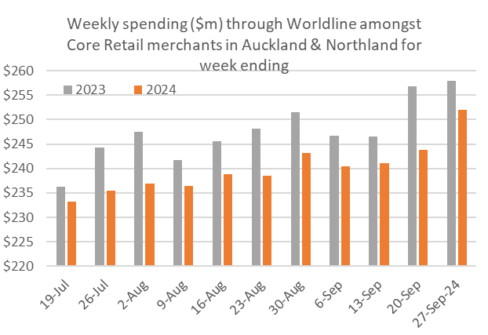
Figure 1: All Cards Auckland and Northland underlying* spending through Worldline for the 11 weeks ending Friday during July-September 2023 and 2024 for core retail excluding hospitality merchants (*underlying excludes large clients moving to or from Worldline)

Meanwhile, in September 2024, no region experienced spending above that seen in September 2023. The largest decline was in Southland (-11.8%) and South Canterbury (-7.4%). Spending declined the least in Nelson (-0.8%), Canterbury (-1.1%) and Waikato (-1.5%).
WORLDLINE All Cards underlying* spending for CORE RETAIL less HOSPITALITY merchants for September 2024
 | Value | Underlying* | Underlying*
Region | transactions $millions | Annual % change on 2023 | Annual % change on 2019
Auckland/Northland | 1,046 | -4.0% | 10.2%
Waikato | 239 | -1.5% | 28.2%
BOP | 188 | -5.5% | 15.7%
Gisborne | 26 | -2.4% | 11.8%
Taranaki | 67 | -2.1% | 29.4%
Hawke's Bay | 105 | -2.4% | 25.4%
Whanganui | 40 | -1.8% | 33.8%
Palmerston North | 87 | -4.1% | 23.5%
Wairarapa | 37 | -2.2% | 26.8%
Wellington | 250 | -3.5% | 10.5%
Nelson | 58 | -0.8% | 17.3%
Marlborough | 36 | -2.8% | 19.8%
West Coast | 20 | -2.0% | 26.3%
Canterbury | 362 | -1.1% | 26.0%
South Canterbury | 50 | -7.4% | 19.5%
Otago | 165 | -2.2% | 19.7%
Southland | 63 | -11.8% | 8.2%
New Zealand | 2,839 | -3.4% | 16.7%
Figure 2: All Cards NZ underlying* spending through Worldline in September 2024 for core retail excluding hospitality merchants (* Underlying excludes large clients moving to or from Worldline)
- ENDS -
Note to editors:
These figures reflect general market trends and should not be taken as a proxy for Worldline‘s market share or company earnings. The figures primarily reflect transactions undertaken within stores but also include some ecommerce transactions. The figures exclude transactions through Worldline undertaken by merchants outside the Core Retail sector (as defined by Statistics NZ).
For more information, contact:
Brendan Boughen
T 027 839 6044
E brendan.boughen.external@worldline.com

ABOUT WORLDLINE IN NEW ZEALAND
We are New Zealand's leading payments innovator. We design, build and deliver payment solutions that help Kiwi business succeed. Whether you’re looking for in store, online or mobile payment solutions or powerful business insights, Worldline is here to help with technology backed by experience. www.worldline.co.nz

About Worldline
Worldline [Euronext: WLN] helps businesses of all shapes and sizes to accelerate their growth journey – quickly, simply, and securely. With advanced payments technology, local expertise and solutions customised for hundreds of markets and industries, Worldline powers the growth of over one million businesses around the world. Worldline generated a 4.6 billion euros revenue in 2023. worldline.com
Worldline’s corporate purpose (“raison d’être”) is to design and operate leading digital payment and transactional solutions that enable sustainable economic growth and reinforce trust and security in our societies. Worldline makes them environmentally friendly, widely accessible, and supports social transformation.
Press Contact
Hélène Carlander
T +33 7 72 25 96 04
E helene.carlander@worldline.com
Follow us

Source: Weather in Auckland - Climate monitor on September 2024 (weatherandclimate.info).

