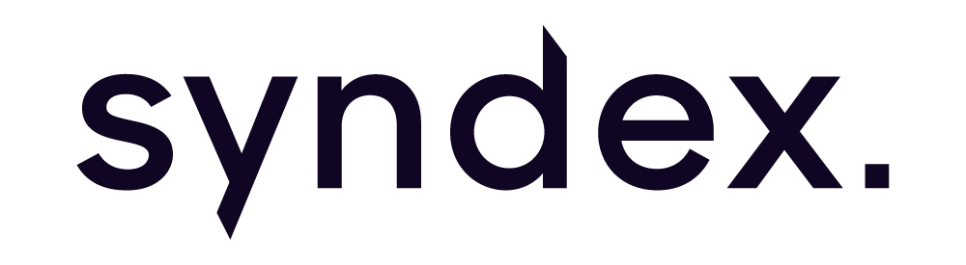

FCX announces strategic partnership with NZ’s private markets platform Syndex
MOU expands private markets opportunities across Australasia

Sydney, 4 June 2024 – FinClear, on behalf of FCX – Australia’s first centralised platform for private market capital – has signed a memorandum of understanding with Syndex, a New Zealand de-centralised private markets platform, to formalise a partnership between the two technology companies.
The partnership is a natural progression in advancing capital raising, administrative, and liquidity capabilities for private companies and their investors in the region. FCX and Syndex will share product and technology developments as well as effectively extending market presence across both territories to better support clients in either country.
Commenting on the partnership, Steve McClean, FCX Director, said “Like us, Syndex sees the considerable opportunity for private markets. There is growing demand for a regulated, seamless exchange for private companies that mirrors listed stock exchanges; for a better way to manage transactions; and to provide access and liquidity for investors to the massive untapped value private markets represent.
“We believe both competition and collaboration will accelerate these developments. This partnership is the product of a shared vision of the future of private markets and a natural expansion of our footprint in New Zealand, where FinClear clients already leverage our parent infrastructure.”
FCX brings to the pairing its proprietary technology based on a distributed ledger structure and advancements in tokenising cash and assets. It also has considerable cash and foreign exchange capabilities along with the capabilities of parent company FinClear – Australia’s leading independent technology and infrastructure provider for financial market access.
Syndex brings strong capabilities in fund administration and deep knowledge of the local market, including its close relationship with the NZX, and experience in cooperative and agricultural securities. Syndex also offers innovative, decentralised private market technology which has been delivering liquidity solutions to private investors, which combined with the investor relations and compliance software utilised by investment managers, has enhanced the ability of private companies and funds to raise capital.
Ross Verry, Syndex Chief Executive, said “We are delighted to be partnering with FinClear to offer clients access to enhanced capabilities and together build the future of private markets in Australasia.
“Private companies are the backbone of both economies. Access to capital is critical to their ongoing growth, so technology that provides investors security and liquidity brings great benefit to companies, unlisted fund managers, investors and the economy. Recent market conditions have highlighted challenges of raising capital and as Australia’s leading independent technology and infrastructure provider for financial markets, the FinClear Group will add new expertise, insights and experience to the continued advancement of private markets. We look forward to bringing the combined proposition to our clients and market participants.

