NZ’s tough retail environment persists as spending in May barely tops year-ago levels

AUCKLAND, 2 June 2022 – Consumer spending figures released by Worldline today show the current tough environment for Kiwi retailers persisted in May.

Consumer spending at Core Retail merchants (excluding Hospitality) in Worldline NZ’s payments network reached $2.873B in May 2022, just 1.1% above the same month last year.

Worldline NZ’s Head of Data, George Putnam, says this annual growth rate is below the 4.0% averaged in the previous four months.

“May 2022 had one less Saturday than May 2021, so that was always going to make it tough to record a high growth rate. However, what these numbers clearly show is an overall low growth rate, with spending falling below levels seen a year ago on several days during the month,” says Putnam.
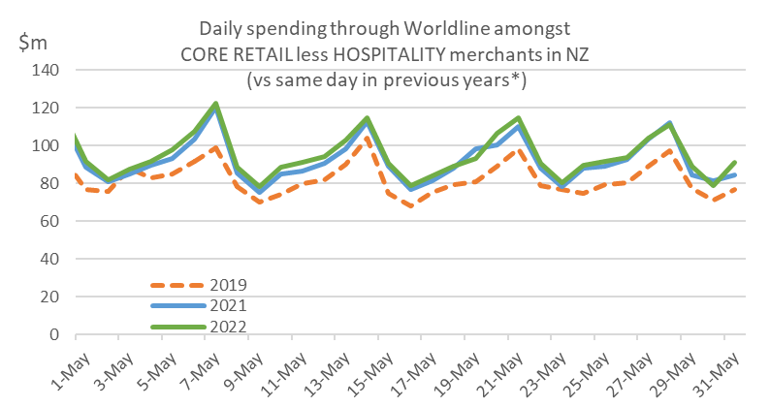
Figure 1: All Cards NZ underlying* daily spending through Worldline for Core Retail excluding hospitality merchants during May 2019, 2021 and 2022 (* Underlying excludes large clients moving to or from Worldline)
“Noticeably, there were a number of merchant groups that were consistently seeing spending running below year-ago levels in May, such as Appliances, Furniture, Apparel, Bookshops and Jewellery,” he says.
“Add to this the effect of inflation creating higher prices that affected this spending, and the overall picture continues to be a tough trading environment for retailers.”
However, Putnam also says that spending at merchants within the Service sectors, such as hairdressers and movie theatres, showed continuing improvement now that consumers were able to get about with fewer COVID-19 restrictions.
“Annual spending growth in May was 3.2% for the Beauty & Hairdressing group, up from the average -1.2% in the first four months of 2022,” he says.
“Spending at Movie Theatres was up 17.8% versus a -6.4% decline previous to this year, while Restaurants/Cafes were still down on last year, but the -11.5% drop in May was an improvement on the -13.7% four-month average.”
Spending in the Hospitality sector, which includes Restaurants/Cafes but also Hotels and Motels, was $888m in May, down 7.4% on May last year.
Regionally, consumer spending outside the Hospitality sector in May was below year-ago levels in Auckland/Northland (-0.9%), Gisborne (-1.3%), Wellington (-1.2%), Marlborough (-0.6%) and Otago (-0.7%).
Compared to pre-Covid times, Core Retail spending growth between May 2019 and May 2022 was highest in Taranaki (+24.4%) and Wairarapa (+23.3%) and lowest in Otago (+8.0%).
WORLDLINE All Cards underlying* spending for CORE RETAIL less HOSPITALITY merchants for May 2022
 | Value | Underlying* | Underlying*
Region | transactions $millions | Annual % change on 2021 | Annual % change on 2019
Auckland/Northland | 1,067 | -0.9% | 9.4%
Waikato | 225 | 5.0% | 18.0%
BOP | 193 | 3.1% | 15.7%
Gisborne | 27 | -1.3% | 9.5%
Taranaki | 66 | 7.4% | 24.4%
Hawke's Bay | 100 | 2.7% | 18.4%
Wanganui | 36 | 3.9% | 22.1%
Palmerston North | 86 | 2.0% | 17.4%
Wairarapa | 36 | 3.3% | 23.3%
Wellington | 280 | -1.2% | 10.2%
Nelson | 56 | 1.9% | 11.0%
Marlborough | 33 | -0.6% | 12.9%
West Coast | 19 | 2.4% | 16.6%
Canterbury | 346 | 4.5% | 16.5%
South Canterbury | 47 | 2.4% | 13.7%
Otago | 145 | -0.7% | 8.0%
Southland | 66 | 3.0% | 13.0%
New Zealand | 2,873 | 1.1% | 12.4%
* Underlying excludes large clients moving to or from Worldline
Figure 2: All Cards NZ annual underlying* spending growth through Worldline May for regional core retail excluding hospitality merchants (* Underlying excludes large clients moving to or from Worldline)
- ENDS -
Note to editors:
These figures reflect general market trends and should not be taken as a proxy for Worldline‘s market share or company earnings. The figures primarily reflect transactions undertaken within stores but also include some ecommerce transactions. The figures exclude transactions through Worldline undertaken by merchants outside the Core Retail sector (as defined by Statistics NZ).

For more information, contact:
Brendan Boughen
T 027 839 6044
E brendan.boughen@paymark.co.nz

ABOUT WORLDLINE IN NEW ZEALAND
We are New Zealand's leading payments innovator. We design, build and deliver payment solutions that help Kiwi business succeed. Whether you’re looking for in store, online or mobile payment solutions or powerful business insights, Worldline is here to help with technology backed by experience. www.paymark.co.nz

About Worldline
Worldline [Euronext: WLN] is the European leader in the payments and transactional services industry and #4 player worldwide. With its global reach and its commitment to innovation, Worldline is the technology partner of choice for merchants, banks and third-party acquirers as well as public transport operators, government agencies and industrial companies in all sectors. Powered by over 20,000 employees in more than 50 countries, Worldline provides its clients with sustainable, trusted and secure solutions across the payment value chain, fostering their business growth wherever they are. Services offered by Worldline in the areas of Merchant Services; Terminals, Solutions & Services; Financial Services and Mobility & e-Transactional Services include domestic and cross-border commercial acquiring, both in-store and online, highly-secure payment transaction processing, a broad portfolio of payment terminals as well as e-ticketing and digital services in the industrial environment. In 2020 Worldline generated a proforma revenue of 4.8 billion euros. worldline.com

PRESS CONTACTs

Hélène Carlander
T +33 (0)7 72 25 96 04
E helene.carlander@worldline.com
Investors Relations
Laurent Marie
T : +33 (0)1 58 01 83 24
E : laurent.marie@worldline.com

Follow us

